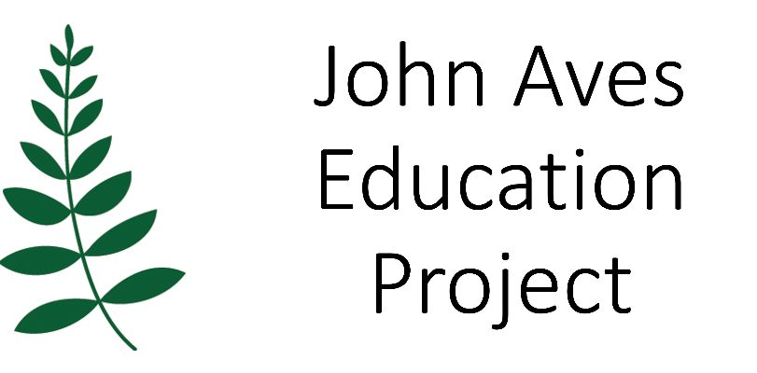Welcome to the Spring 2023 Newsletter
Thank you for your continuing support of the John Aves Education Project (JAEP).
To date JAEP has funded 74 young adults (56 female, 18 male) from Dheisheh Palestinian Refugee Camp, in Bethlehem, to study for an undergraduate degree.
We continue to be hugely appreciative of the support from 45 regular standing order donors.
This newsletter will give you updates about:
- Recent JAEP monitoring visit to Al Quds University (AQU), Bethlehem University (BU), and Dheisheh Camp (DC)
- Success with The Big Give Christmas Challenge
- 2023 Fund fundraising events
JAEP monitoring visit from 18th – 28th February
We were delighted to return to both universities and DC. This academic year we are funding 21 students at AQU and 5 at BU.
The purpose of our visit was to:
- Spend time with JAEP students
- Build on our relationships at both universities
- Progress plans to fund students at Dar Al Kalima Creative Art University in Bethlehem (DaK)
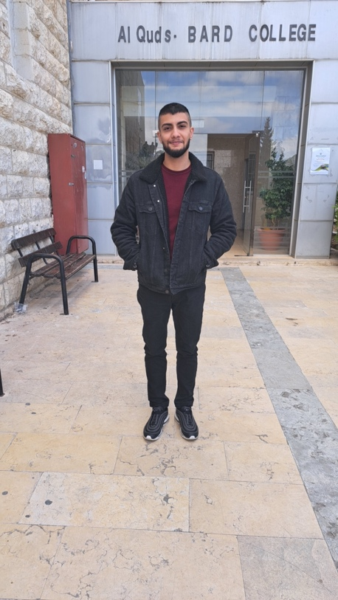
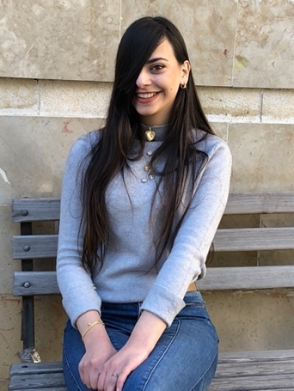
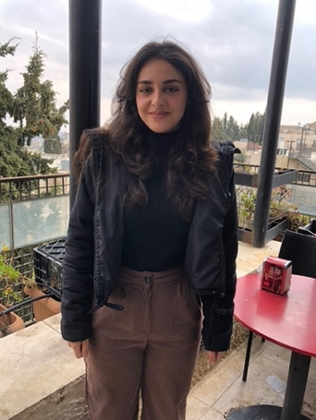
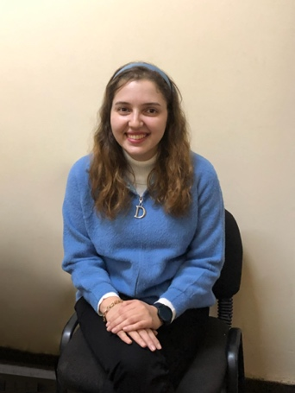
JAEP students
From 19th – 22nd February we spent each day at AQU, travelling daily from Jerusalem. From 23rd – 27th February we stayed in Ibdaa Community Centre in DC. John was living and volunteering here at the time of his death in 2004.
When at AQU we join students in their classes including speaking to their tutors, all of whom say the student is hard-working and doing well. We can also witness the students’ attitude to learning, the passion for their subject and determination to succeed. There by ensuring our funders are receiving value for money.
While staying in DC we spent a morning at BU, chatting to all students currently receiving a JAEP scholarship, and an afternoon in Ibdaa with AQU JAEP students taking photos and interviewing students on video.
Tariq AQU Economics and Finance Bards College 2021 - 2024
Liz joined Tariq for a class on Schools of Economic Theories. A very small class of only 6 students. A Powerpoint presentation was given in English by another student. Tariq was very attentive answering the lecturer’s questions and taking notes. Before the class Tariq told me that as soon as he graduates he will travel to the United States where his father and uncles are living. He plans to start his own business there and ultimately return to the Occupied Palestinian Territories to run a business which provides local employment.
Dana AQU Architectural Engineering 2021 - 2024
Anne joined Dana for a practical design class taught by two local architects. The students were working in groups to design either a Court House or Municipal Building, the local area has neither. The brief was to design the building so the local population could see democracy in practice, the politics of their situation is never far away. In groups these were presented to the class for comment. Dana was very engaged in preparing their group presentation. Dana has had cancer and has a prosthetic eye.
Diana BU Midwifery 2021 - 2024
Diana was named after Princess Diana.
Her father is a legal labourer in Israel, so receives a higher and more secure wage than if he worked in Palestine.
Diana shares a laptop with 6 siblings.
We spoke about how students are always smiling. Diana said that is how we respond to our situation, with a refusal to give up hope, to laugh and joke. Education is the only way.
Nibal AQU Software Engineering 2012 - 2014
Nibal was one of the very first JAEP funded students.
Nibal works in Israel as a Senior Software Engineer for a US Global Networking Company.
Working in Israel means her salary is higher. Family and friends ask for financial help to fund their studies, which she gives. When they bring money to pay back the debt, Nibal always says no, but asks the person to give the money to someone else who needs help, describing this as a chain reaction.
Build on our relationships at both universities
At both universities we receive the most wonderful hospitality. Our link staff clear their diaries to spend time each day with us, including updating us of any student issues that they have alerted us to during the academic year. We planned the 2023/24 scholarship call with them.
At AQU the President, Prof. Imad Abu Kishek always makes time to meet and thank us, saying no other funders are keen to get to know the students, including joining their classes, and absolutely no other funders stay in a refugee camp with their students. JAEP meets the president of AQU.
Progress plans to fund students from Dar Al Kalima Creative Arts University in Bethlehem (DaK)
Our links in Ibdaa set up and joined us for a very productive meeting at DaK with the Director of Student Affairs. The next step is to set up by a zoom meeting with this director and the Finance Director. Creative students will broaden our curriculum subject range and daring to dream, provide some imaginative films/artwork for JAEP!!
Fundraising
The Big Give Christmas Campaign 29th November – 6th December 2022
Thank you to all who attended our very successful launch of The Big Give Christmas Campaign at Ipswich Road URC on 29 November. We are delighted to report that we raised £5292.
Sunday 21st May, 1pm to 4.30pm Bishop’s House Open Garden NR3 1SB
All proceeds to JAEP
A relaxing afternoon for all the family with; homemade cakes and refreshments, live entertainment, traditional games, children’s crafts, butterfly trail, cake stall, tombola, plant sale.
Sunday 3rd September, 11am – 5pm Mannington Hall and Gardens
Proceeds shared with The Matthew Project
A day of fun for all the family. Activities include include arts and craft, live music, a vintage car exhibition, children’s games and play area with activities, plus a fantastic range of refreshments including a BBQ and ice cream. The 20-acre estate offers walks, trails and beautifully landscaped gardens. The 15th Century Hall will also have both floors available to visit.
Beginning of May, four new designs for JAEP greeting cards available
Thank you very much for reading this Newsletter and for your continued support.
We look forward to seeing you on 21st May and 3rd September!
www.jaep.org.uk info@jaep.org.uk Charity Number 1170414

